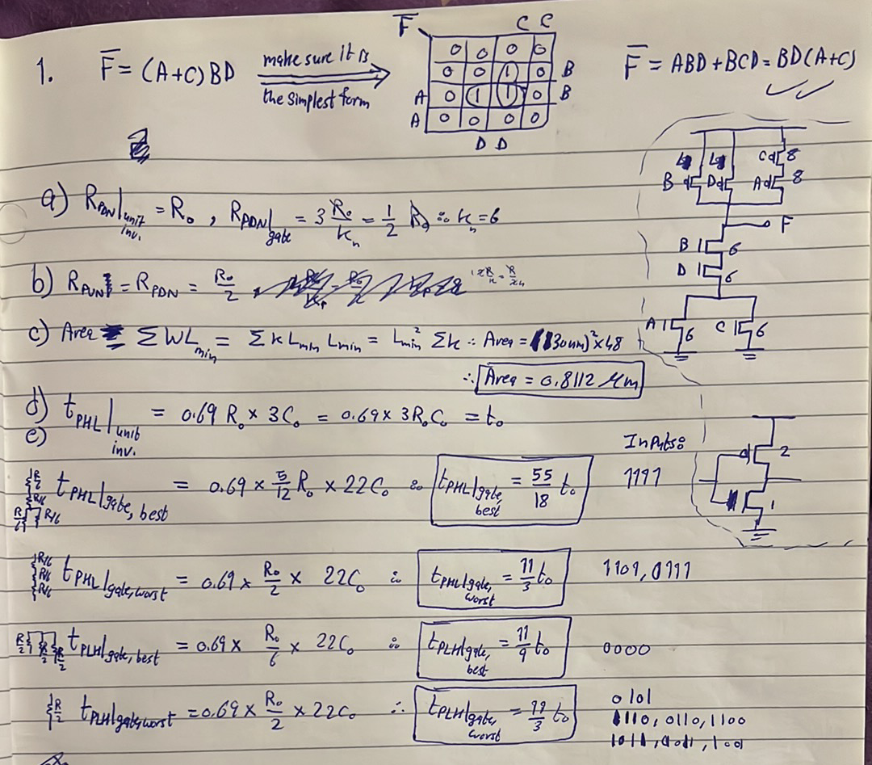
Note: make sure you arrange transistors in PUN and PDN so that minimum number of transistors are next to the output node to minimize capacitance.
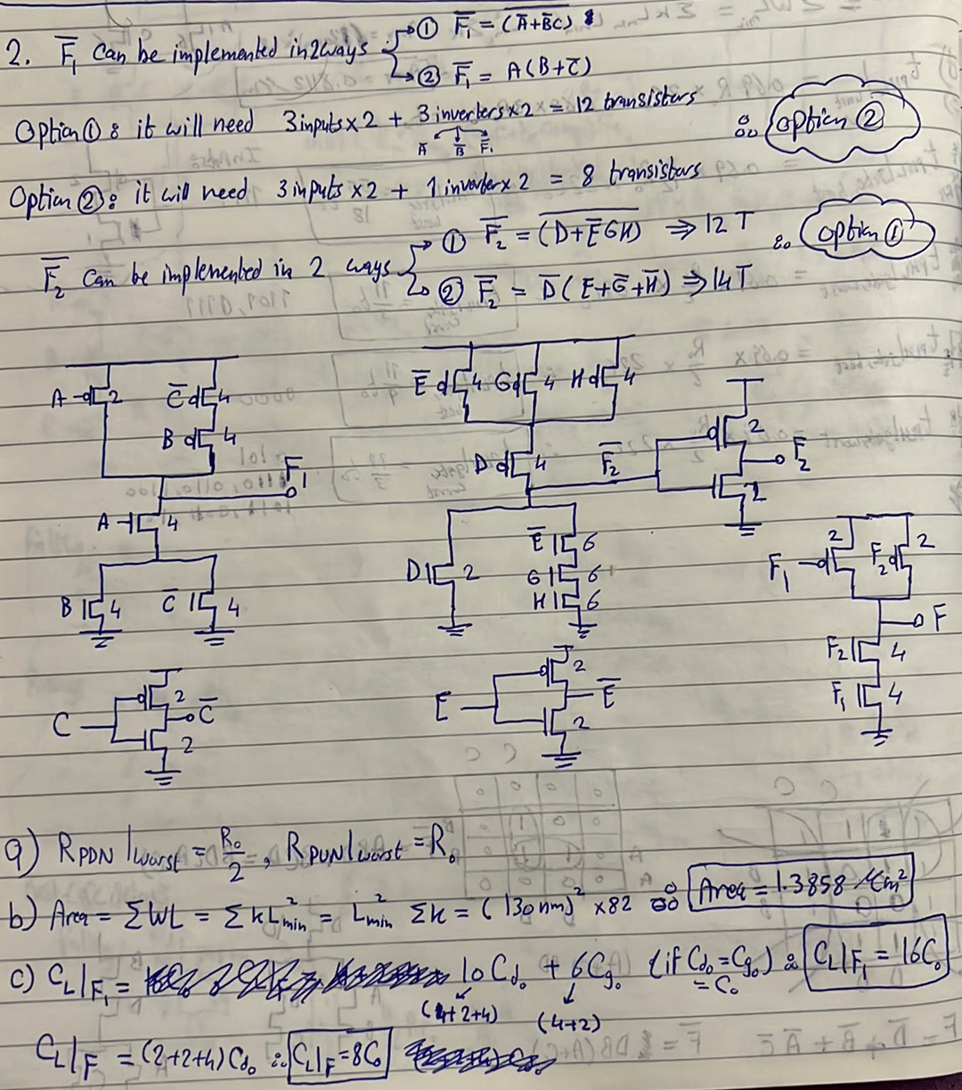
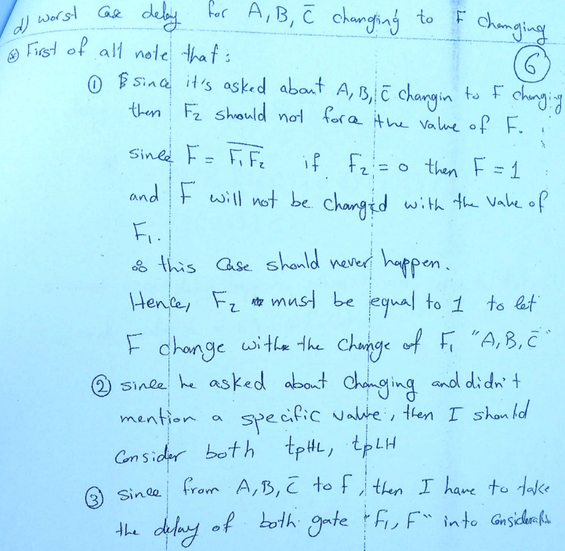
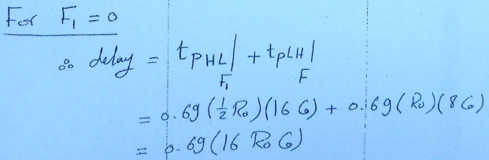
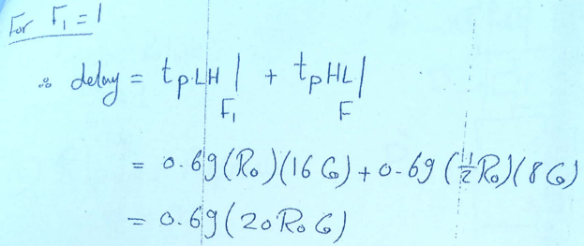
$∴$ Worst-case delay for A, B, C’ changing to F changing is $0.69*20R_{o}C_{o}.$
